

Subscribe to DeepL Pro to edit this document.  
Visit [www.DeepL.com/pro](https://www.deepl.com/pro?cta=edit-document)for more information.

# Target:

Uploading a file to an S3 bucket

# Services:

- IAM

- API Gateway

- S3 Bucket

# Websites:

[- https://docs.aws.amazon.com/de_de/apigateway/latest/developerguide/integrating-api-with-aws-services-s3.html](https://docs.aws.amazon.com/de_de/apigateway/latest/developerguide/integrating-api-with-aws-services-s3.html)

# Quick Guide:

## IAM role

### Establishment of a new role:

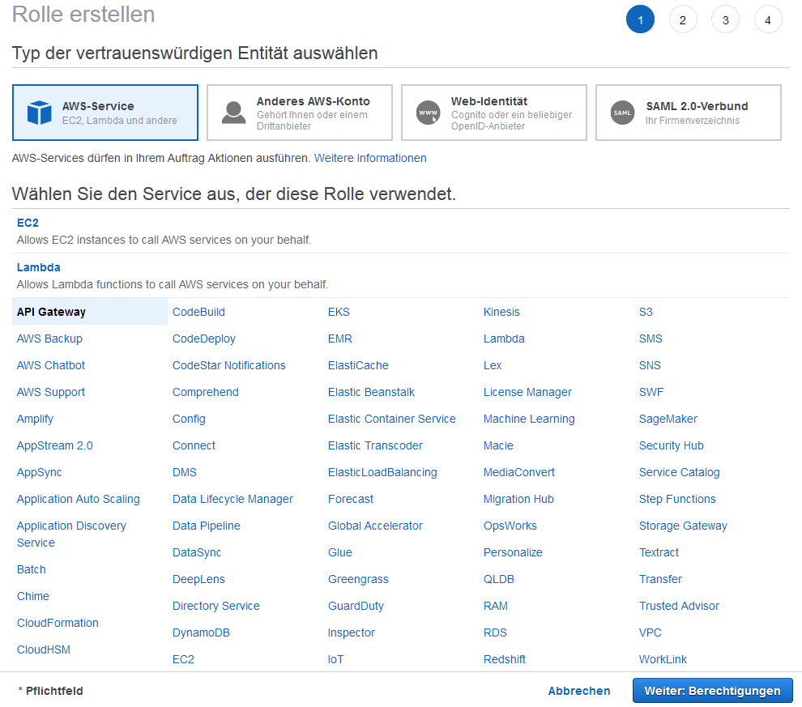

### Add Policy for PUT Objects



{

}, "version": "2012-10-17",

{ "statement": [

{

}, "effect": "allow",

{ "action": "s3:Put*",

"Resource": "*"

}

]

}

### Result

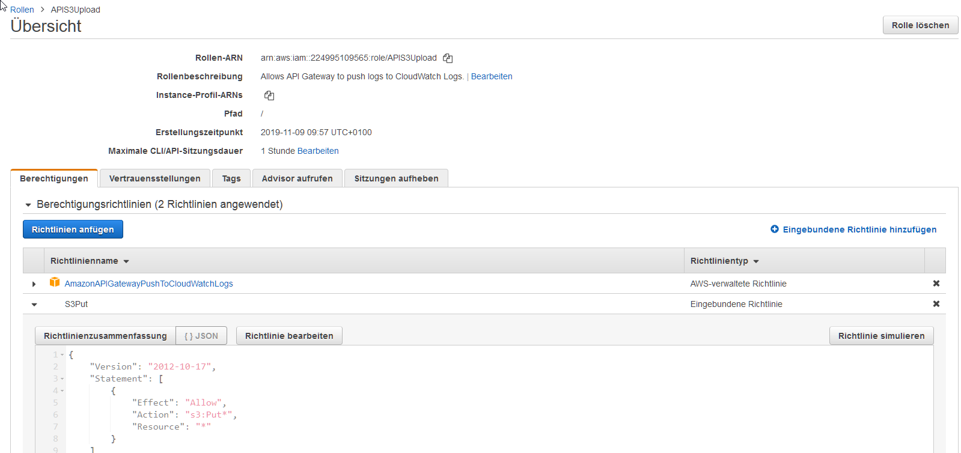

## S3 Bucket

Create a new bucket without special features.



## API Gateway

### Creation of a new API gateway

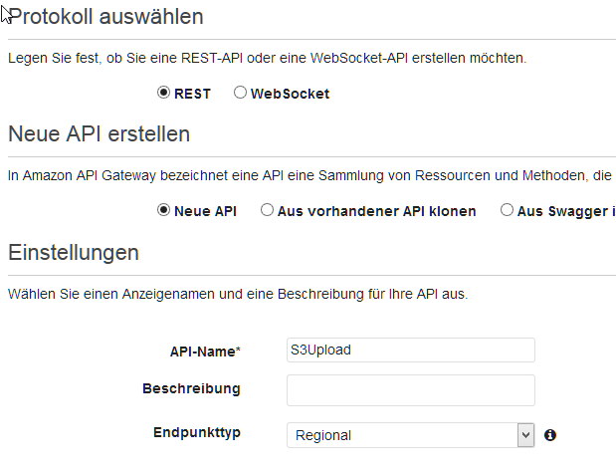

### Create new resource

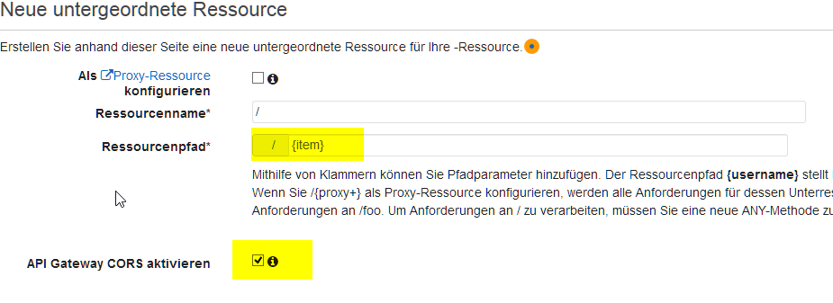

### Create new method POST

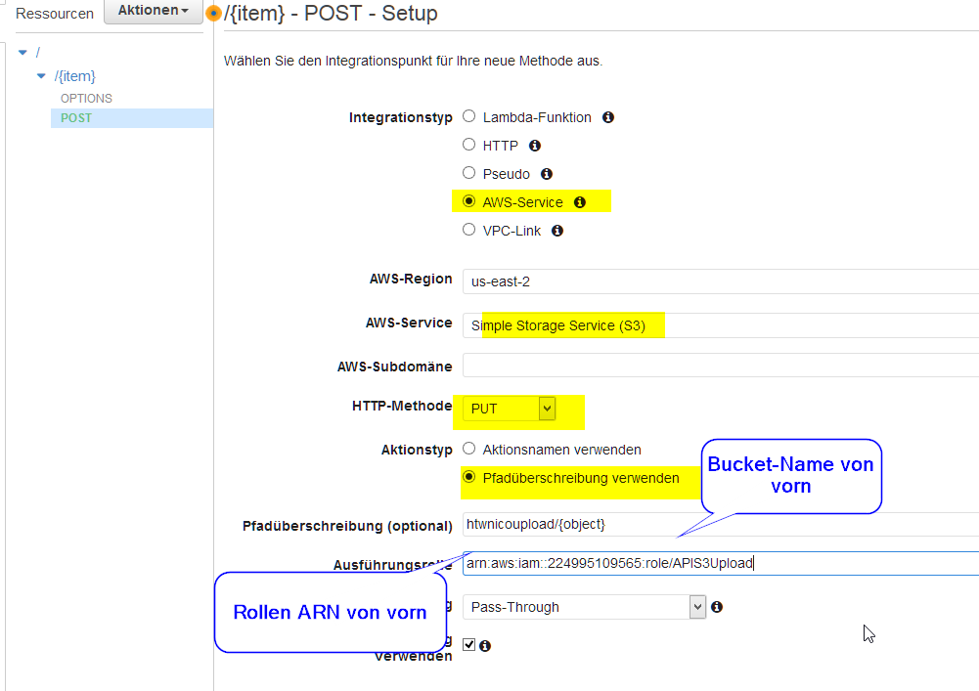

### Set URL Parameter Mapping

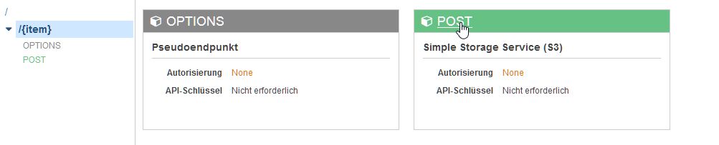

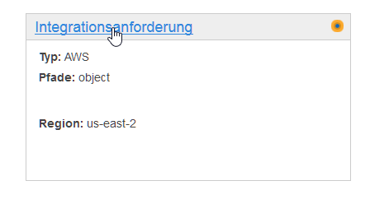

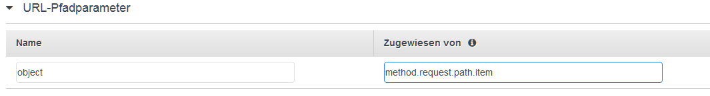

### Setting that binary files in the body are okay

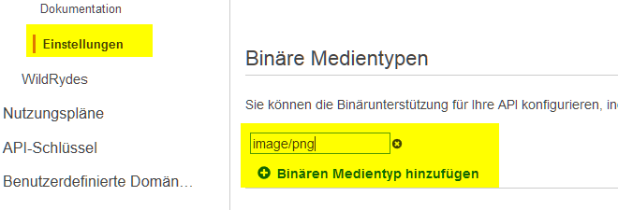

### Providing the API

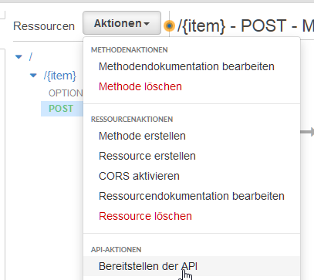

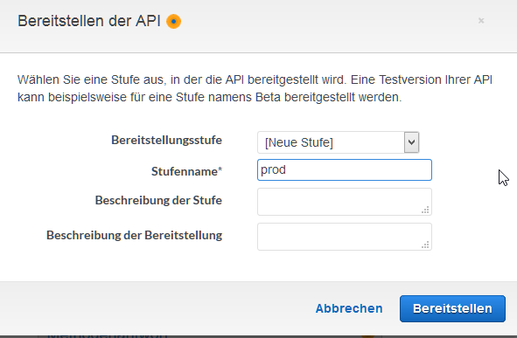

# Testing

## Retrieving the URL

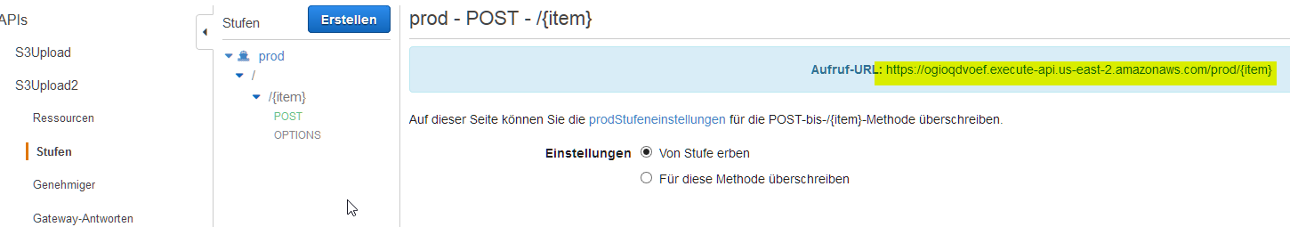

## Input in Postman

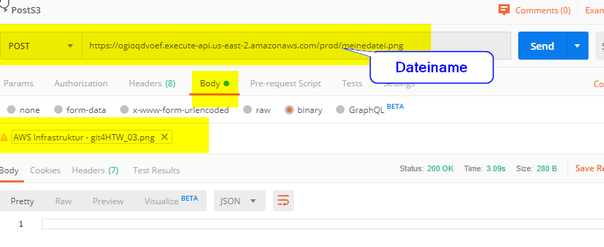

### Test on S3 Bucket

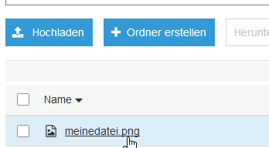

Press refresh if necessary:

